**Practical 3:**

**Objective: Finding roots of equations: Bisection Method**

The bisection method in mathematics is a root-finding method that repeatedly bisects an interval and then selects a subinterval in which a root must lie for further processing. It is a very simple and robust method, but it is also relatively slow.

The method is applicable for numerically solving the equation $f(x) = 0$  for the  [real](https://en.wikipedia.org/wiki/Real_number" \o "Real number) variable $x$ , where $f$  is a [continuous function](https://en.wikipedia.org/wiki/Continuous_function) defined on an interval $[a, b]$ and where $f(a)$  and $f(b)$  have opposite signs. In this case $a$  and $b$  are said to bracket a root since, by the [intermediate value theorem](https://en.wikipedia.org/wiki/Intermediate_value_theorem), the continuous function $f$  must have at least one root in the interval $(a, b)$.

**Initial Requirements:** We have an initial bound $[a, b]$ on the root, that is, f(*a*) and (*b*) have opposite signs.

**Iteration Process:** Given the interval $[a, b]$, define $c = (a + b)/2$. Then

* if $f(c) = 0$ (unlikely in practice), then halt, as we have found a root,
* if $f(c)$ and $f(a)$ have opposite signs, then a root must lie on $[a, c]$, so assign $b = c$ ,
* else $f(c)$ and $f(b)$ must have opposite signs, and thus a root must lie on $[c, b]$, so assign $a = c$ .

**Halting Conditions:** There are three conditions which may cause the iteration process to halt:

1. As indicated, if $f(c) = 0$.
2. We halt if both of the following conditions are met:
   * The width of the interval (after the assignment) is sufficiently small, that is *b* - *a* < εstep, and ( ex)a=0.111111 –b= 0.111118)
   * The function evaluated at one of the end point || or || < εabs.
3. If we have iterated some maximum number of times, say *N*, and have not met Condition 1, we halt and indicate that a solution was not found.

If we halt due to Condition 1, we state that $c$ is our approximation to the root. If we halt according to Condition 2, we choose either $a$  or $b$ , depending on whether || < | or | > ||, respectively.

If we halt due to Condition 3, then we indicate that a solution may not exist (the function may be discontinuous).

**Sample Pseudo-code :**

INPUT: Function *f*, endpoint values *a*, *b*, tolerance *TOL(-=diffent from stoping criteria)*, maximum iterations *NMAX*

CONDITIONS: *a* < *b*, either *f*(*a*) < 0 and *f*(*b*) > 0 or *f*(*a*) > 0 and *f*(*b*) < 0

OUTPUT: value which differs from a root of *f*(*x*)=0 by less than *TOL*

*N* ← 1

**While** *N* ≤ *NMAX* *# limit iterations to prevent infinite loop*

*c* ← (*a* + *b*)/2 *# new midpoint*

**If** *f*(*c*) = 0 or (*b* – *a*)/2 < *TOL* **then** *# solution found*

Output(*c*)

**Stop**

**EndIf**

*N* ← *N* + 1 *# increment step counter*

**If** sign(*f*(*c*)) = sign(*f*(*a*)) **then** *a* ← *c* **else** *b* ← *c* *# new interval*

**EndWhile**

Output("Method failed.") *# max number of steps exceeded*

**Partial Code (MATLAB):**

>> format long

>> eps_abs = 1e-5;

>> eps_step = 1e-5;

>> a = 0.0;

>> b = 2.0;

>> while (b - a >= eps_step || ( abs( f(a) ) >= eps_abs && abs( f(b) ) >= eps_abs ) )

c = (a + b)/2;

if ( f(c) == 0 )

break;

elseif ( f(a)*f(c) < 0 )

b = c;

else

a = c;

end

end

**Part A:**

Consider finding the root of $f(x) = x^{2} - 3$. Let εstep = 0.01, εabs = 0.01 (torelence val)and start with the interval [1, 2].

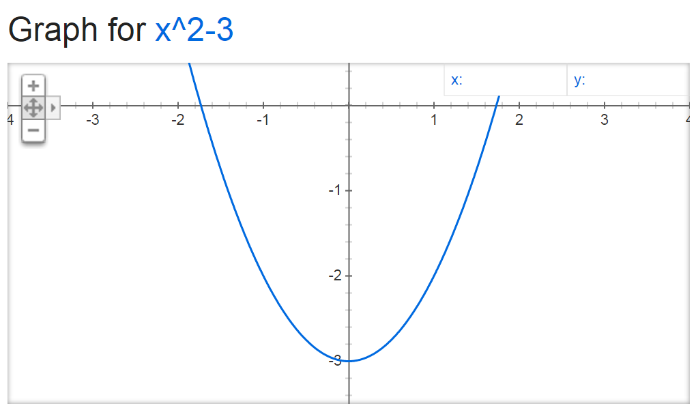

1. Write a program to compute $f(x)$.

Output format:

|  |  |  |  |  |  |  |  |
| --- | --- | --- | --- | --- | --- | --- | --- |
| $$a$$ | $$b$$ | $$f(a)$$ | $$f(b)$$ | $$c=(a+b)/2$$ | $$f(c)$$ | **Update** | $$b-a$$ |
| **1.0** | **2.0** | **-2.0** | **1.0** | **1.5** | **-0.75** | **a=c** | **0.5** |
| **1.5** | **2.0** | **-0.75** | **1.0.** | **1.75** | **0.0625** | **b=c** | **0.25** |
| **1.5** | **1.75** | **-0.75** | **0.0625** | **1.625** | **-0.35938** | **a=c** | **0.125** |
| **1.625** | **1.75** | **-0.35938** | **0.0625** | **1.6875** | **-0.15234** | **a=c** | **0.0625** |
| **1.6875** | **1.75** | **-0.15234** | **0.0625** | **1.71875** | **-0.0459** | **a=c** | **0.03125** |
| **1.71875** | **1.75** | **-0.0459** | **0.0625** | **1.73438** | **0.00806** | **b=c** | **0.01563** |
| **1.71875** | **1.73438** | **-0.0459** | **0.00806** | **1.72656** | **-0.01898** | **a=c** | **0.00781** |

1. What is your approximate of the root?

Root : c= 1.73438

**root : c = 1.72656 X**

**Part B:**

Consider finding the root of $f(x) = e^{-x}(3.2 sin(x) - 0.5 cos(x))$ on the interval $[3, 4]$, this time with εstep  = 0.001, εabs = 0.001 .

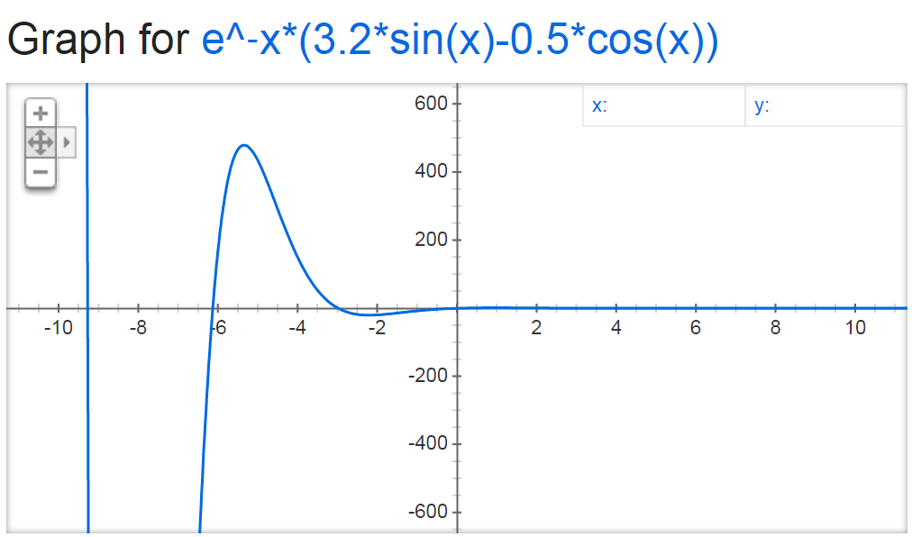

1. Write a program to compute $f(x)$.

Output format: X틀림 (pow(x,-1) 이 아니라 exp(-x)로 해야함)

|  |  |  |  |  |  |  |  |
| --- | --- | --- | --- | --- | --- | --- | --- |
| $$a$$ | $$b$$ | $$f(a)$$ | $$f(b)$$ | $$c=(a+b)/2$$ | $$f(c)$$ | **Update** | $$b-a$$ |
| **3** | **4** | **0.31553** | **-0.52374** | **3.5** | **-0.18694** | **b=c** | **0.5** |
| **3** | **3.5** | **0.31553** | **-0.18694** | **3.25** | **0.04641** | **a=c** | **0.25** |
| **3.25** | **3.5** | **0.04641** | **-0.18694** | **3.375** | **-0.07517** | **b=c** | **0.125** |
| **3.25** | **3.375** | **0.04641** | **-0.07517** | **3.3125** | **-0.01556** | **b=c** | **0.0625** |
| **3.25** | **3.3125** | **0.04641** | **-0.01556** | **3.28125** | **0.01514** | **a=c** | **0.03125** |
| **3.28125** | **3.3125** | **0.01514** | **-0.01556** | **3.29688** | **-0.00028** | **b=c** | **0.01563** |
| **3.28125** | **3.29688** | **0.01514** | **-0.00028** | **3.28906** | **0.00741** | **a=c** | **0.00781** |
| **3.28906** | **3.29688** | **0.00741** | **-0.00028** | **3.29297** | **0.00356** | **a=c** | **0.00391** |
| **3.29297** | **3.29688** | **0.00356** | **-0.00028** | **3.29492** | **0.00164** | **a=c** | **0.00195** |
| **3.29492** | **3.29688** | **0.00164** | **-0.00028** | **3.2959** | **0.00068** | **a=c** | **0.00098** |

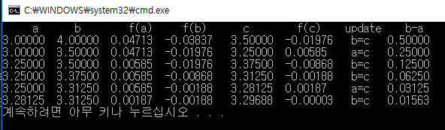

1. What is your approximate of the root?

Root of x = 3.29688

**Root : c=3.2959 X**

**Part C:**

Solve by using the bisection method: $f(x) = sin(x)$ starting with [1, 99], εstep = εabs = 0.00001.

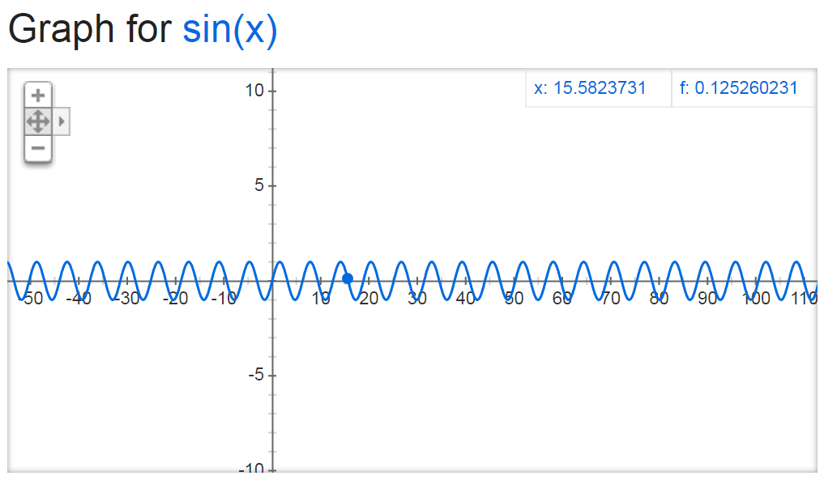

1. Write a program to compute $f(x)$.

Output format:

|  |  |  |  |  |  |  |  |
| --- | --- | --- | --- | --- | --- | --- | --- |
| $$a$$ | $$b$$ | $$f(a)$$ | $$f(b)$$ | $$c=(a+b)/2$$ | $$f(c)$$ | ***Update*** | $$b-a$$ |
| **1** | **99** | **0.84147** | **-0.99921** | **50** | **-0.26237** | **b=c** | **49** |
| **1** | **50** | **0.84147** | **-0.26237** | **25.5** | **0.35906** | **a=c** | **24.5** |
| **25.5** | **50** | **0.35906** | **-0.26237** | **37.75** | **0.05087** | **a=c** | **12.25** |
| **.** | **.** | **.** | **.** | **.** | **.** | **.** | **.** |
| **40.84070** | **40.84071** | **0** | **-0.00001** | **40.84071** | **-0.00000** | **b=c** | **0.00001** |

1. What is your approximate of the root?

We cannot get roots of this f(x) by bisection method.

Because there are too many roots in the domain [1,99] but we can only get one root by bisection method.